EXPERIMENT 1: WINDOWS FUNDAMENTALS

AIM

To understand the basics of the Windows operating system, including its interface, system tools, and security features.

PROCEDURE

- Study Windows interface, file system (NTFS), and user account management.
- Explore system tools like Task Manager, Control Panel, and Computer Management.
- Analyze Windows utilities and configurations.
- Learn built-in security features like UAC and system protection.

QUESTIONS

WINDOWS FUNDAMENTALS 1

TASK 1 - Windows Editions

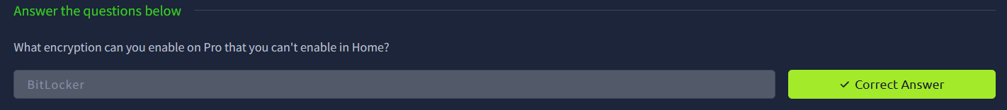

TASK 2 - The Desktop (GUI)

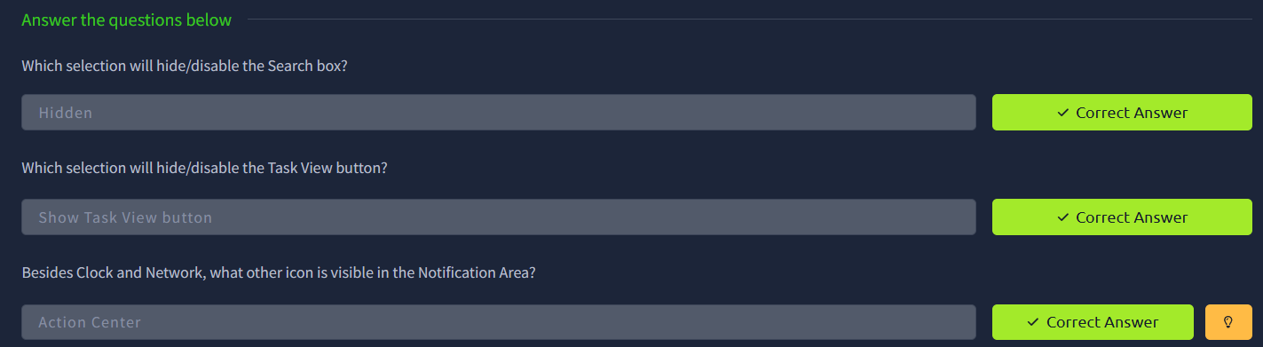

TASK 3 - The File System

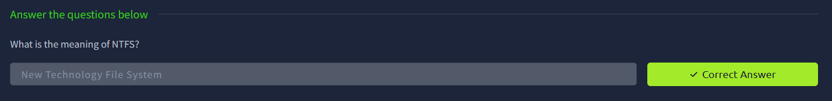

TASK 4 - The Windows\System32 Folders

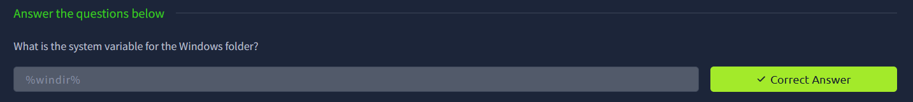

TASK 5 - User Accounts, Profiles, and Permissions

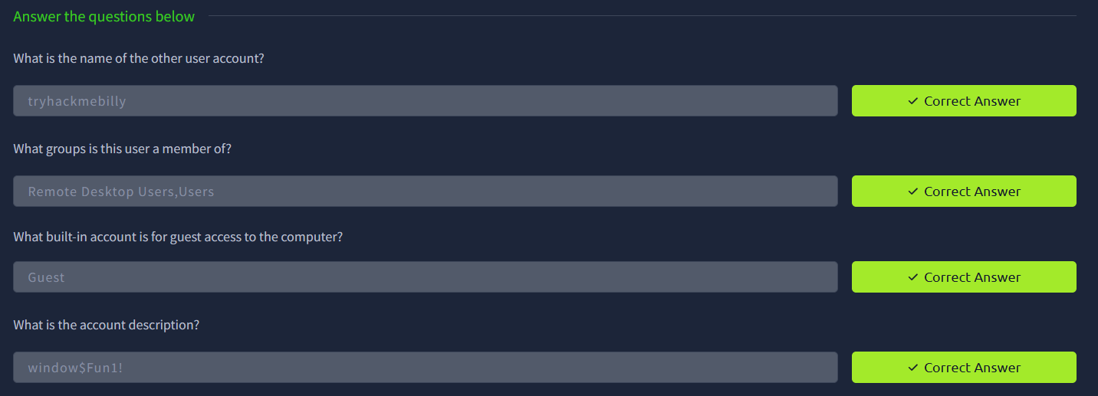

TASK 6 - User Account Control

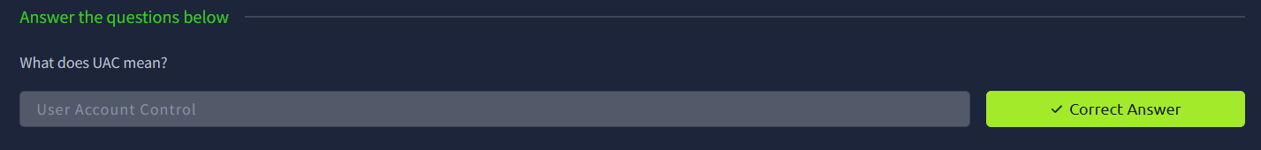

TASK 7 - Settings and the Control Panel

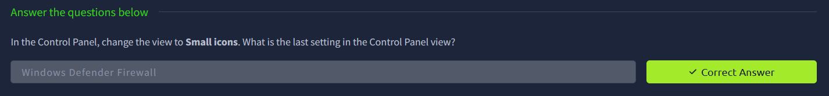

TASK 8 - Task Manager

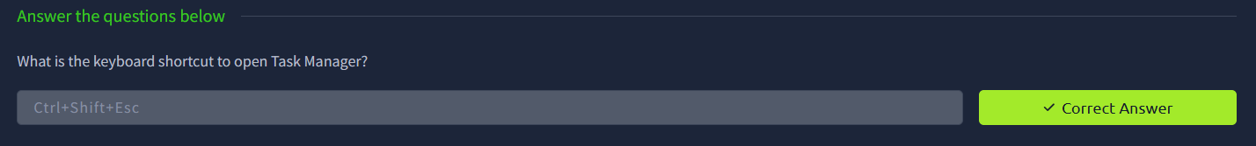

WINDOWS FUNDAMENTALS 2

TASK 1 - System Configuration and Advanced System Settings

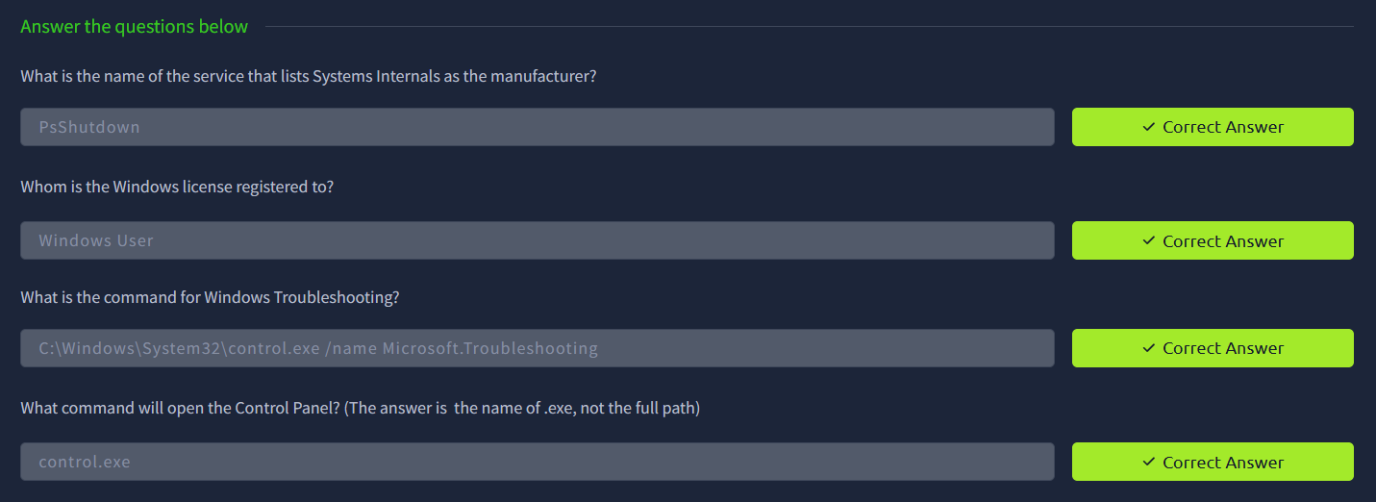

TASK 2 - Change UAC Settings

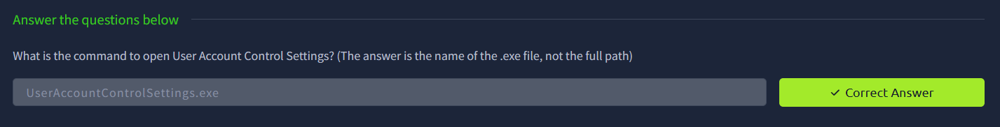

TASK 3 - Computer Management

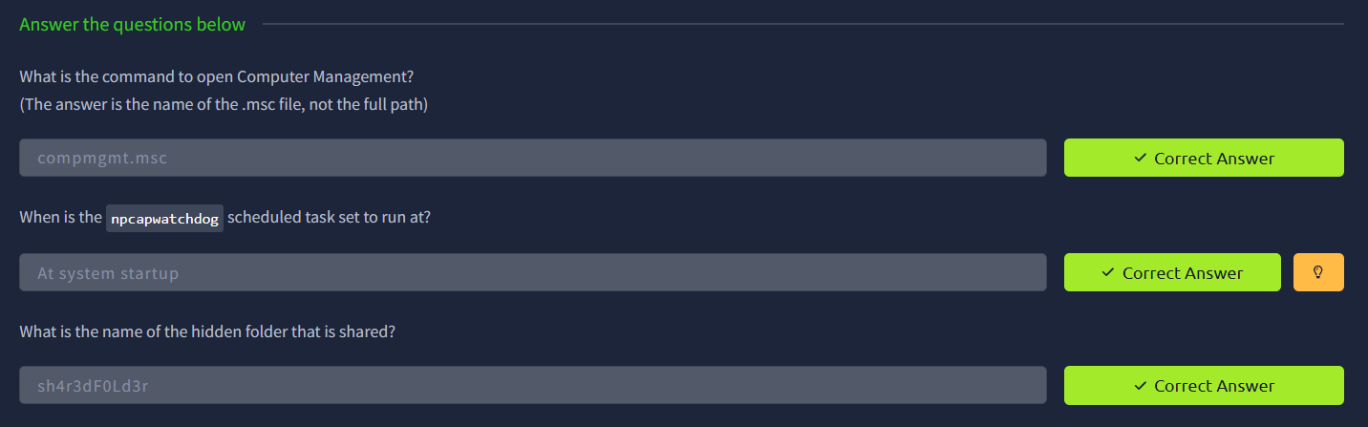

TASK 4 - System Information

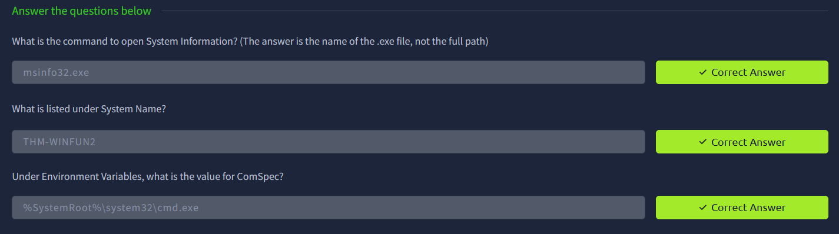

TASK 5 - Resource Monitor

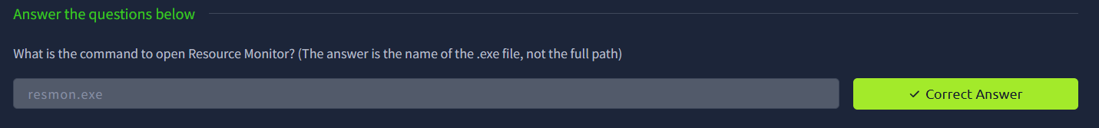

TASK 6 - Command Prompt

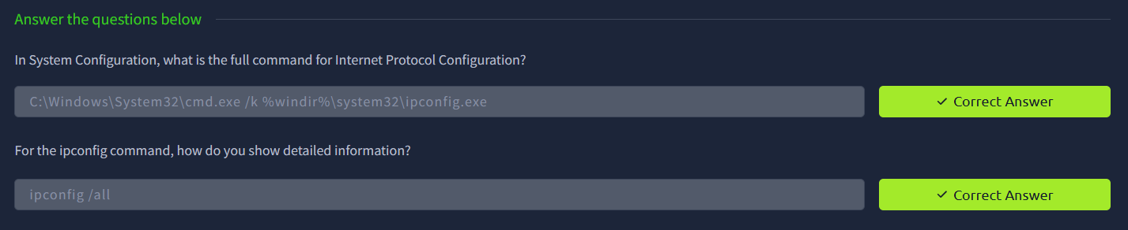

TASK 7 - Registry Editor

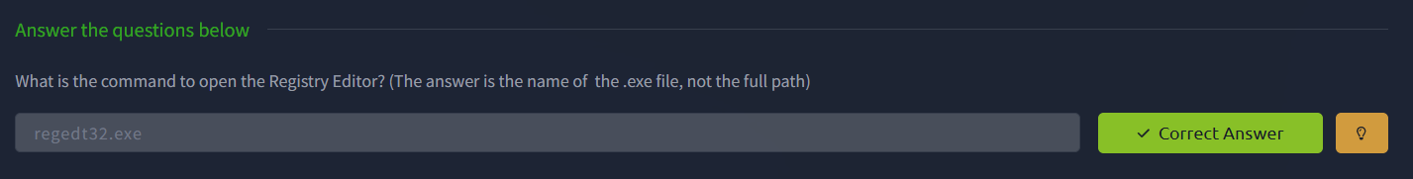

WINDOWS FUNDAMENTALS 3

TASK 1 - Windows Updates

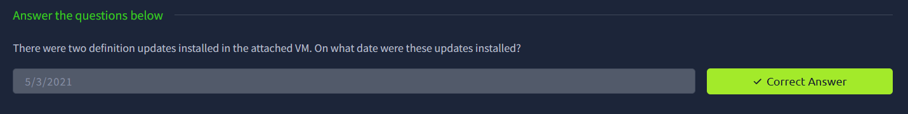

TASK 2 - Windows Security

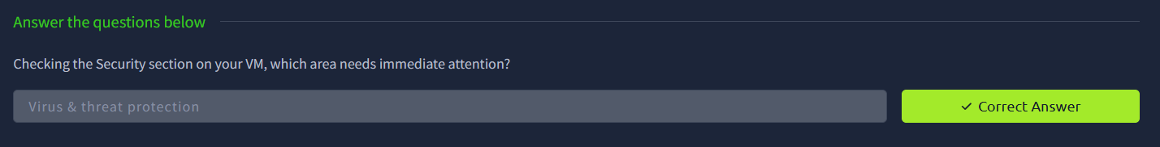

TASK 3 - Virus & Threat Protection

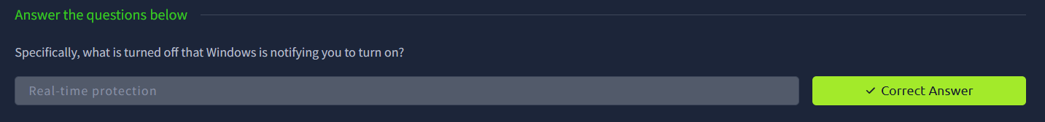

TASK 4 - Firewall & Network Protection

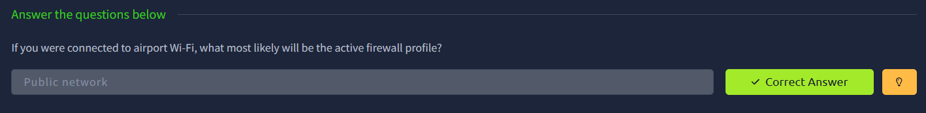

TASK 5 - Device Security

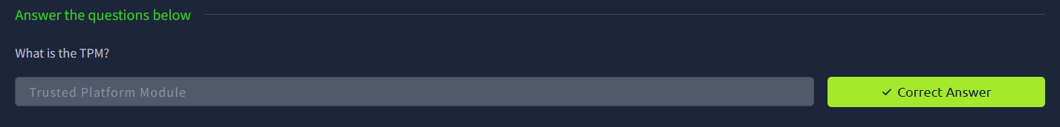

TASK 6 - BitLocker

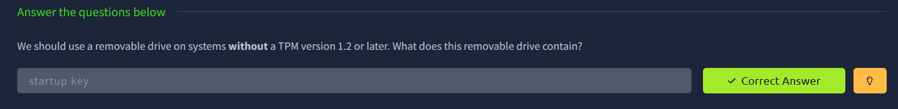

TASK 7 - Volume Shadow Copy Service

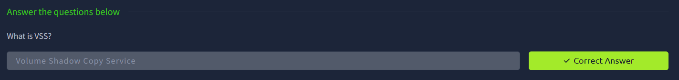
RESULT

Gained knowledge of Windows environment, system tools, and security features, and understood how to manage and secure a Windows system.

